**Table of Contents**

**1. Setting up Maven Project 1**

**2. Create a pom.xml 4**

**3. Create a feature file 6**

**4. Execute the Cases 9**

**5. Reports 17**

**1. Create a Maven Project.**

Open Eclipse Editor install maven plugin from market place or you can directly add selenium, cucumber and junit jars through build path .For this framework Maven was used.

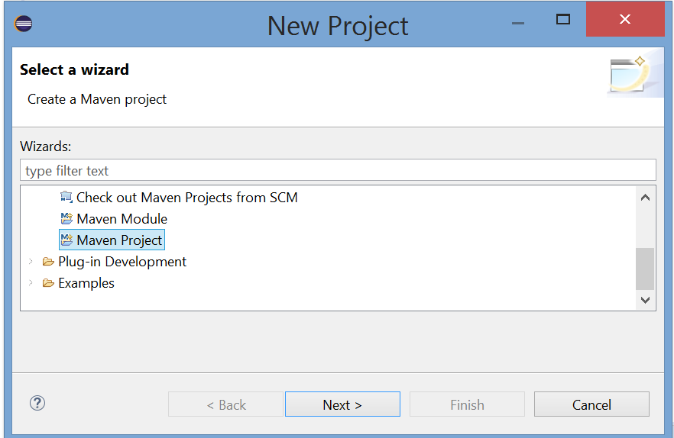

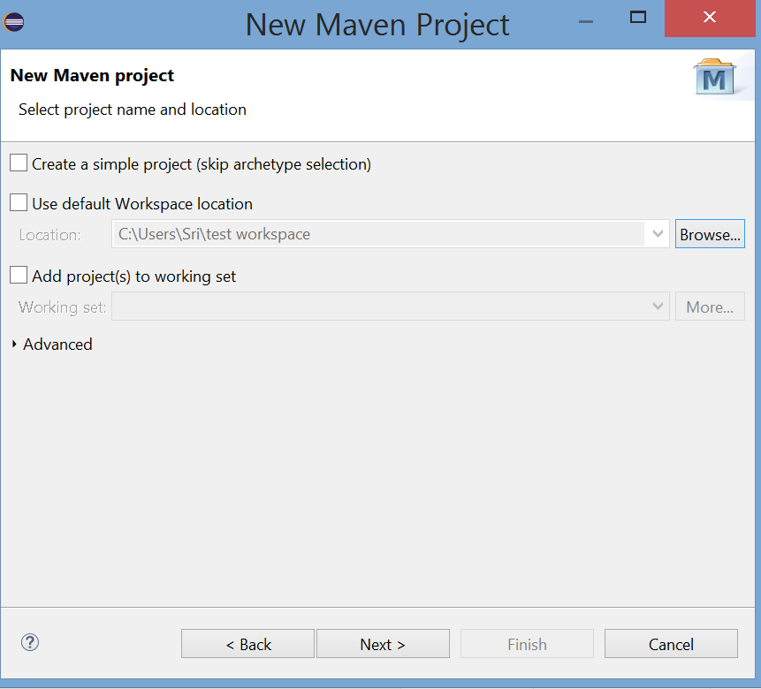

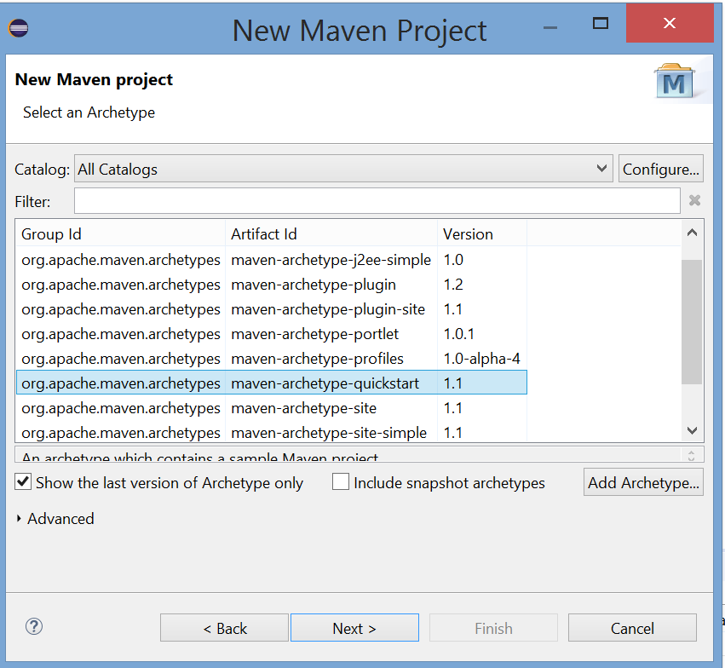

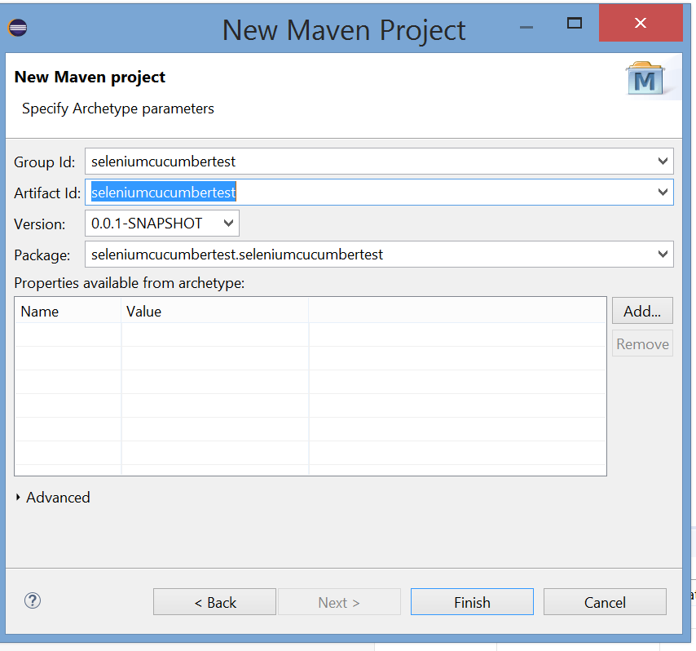

The Package Explorer should look like this.

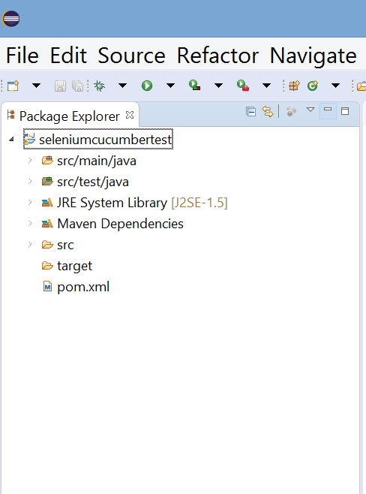

**2. Create a pom.xml**

Pom.xml is an xml file with all the configuration mentioned that is required by the project. It defines the model of the page.

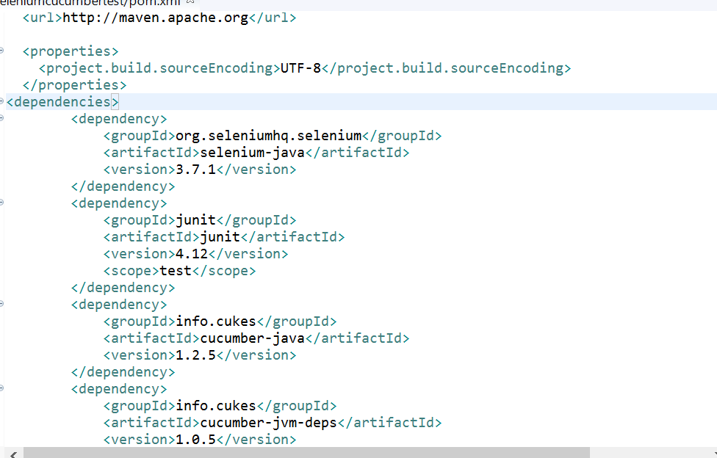

Right click and click Maven and Update Project

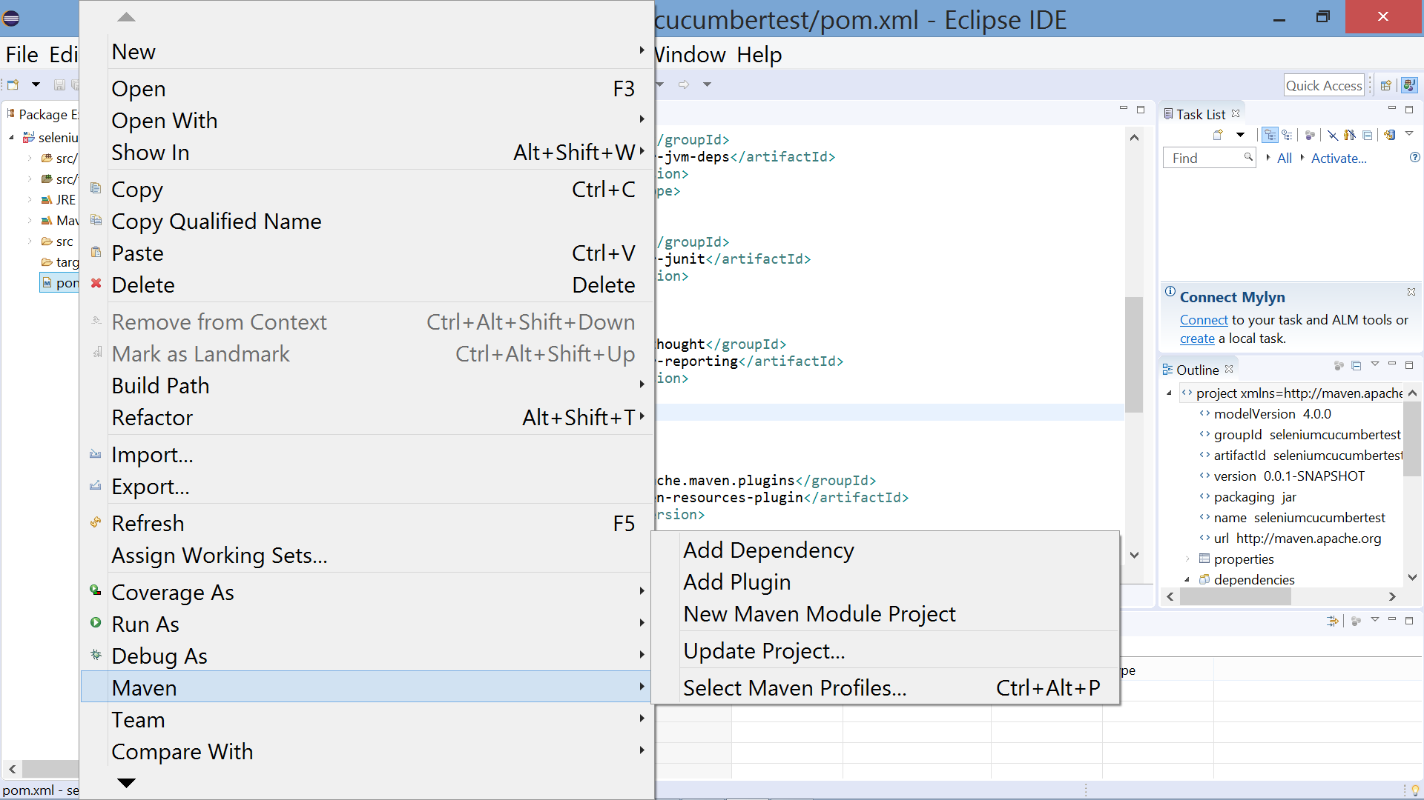

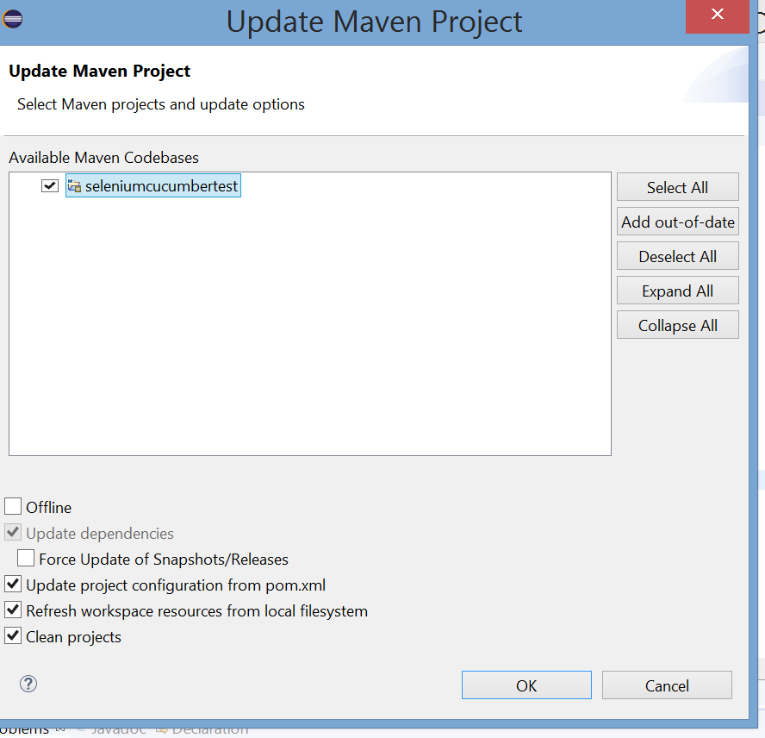

Now the Maven Dependencies are all added to the project.

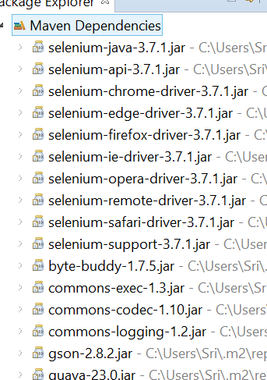

**3. Create a Feature file.**

Create a package feature with a feature file test.feature

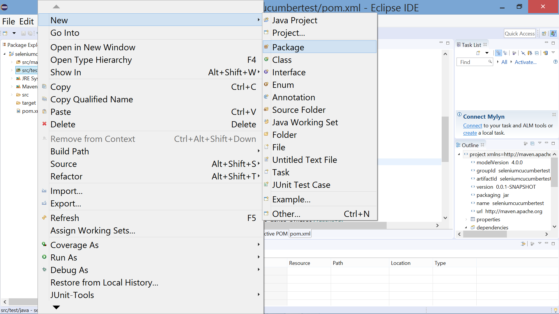

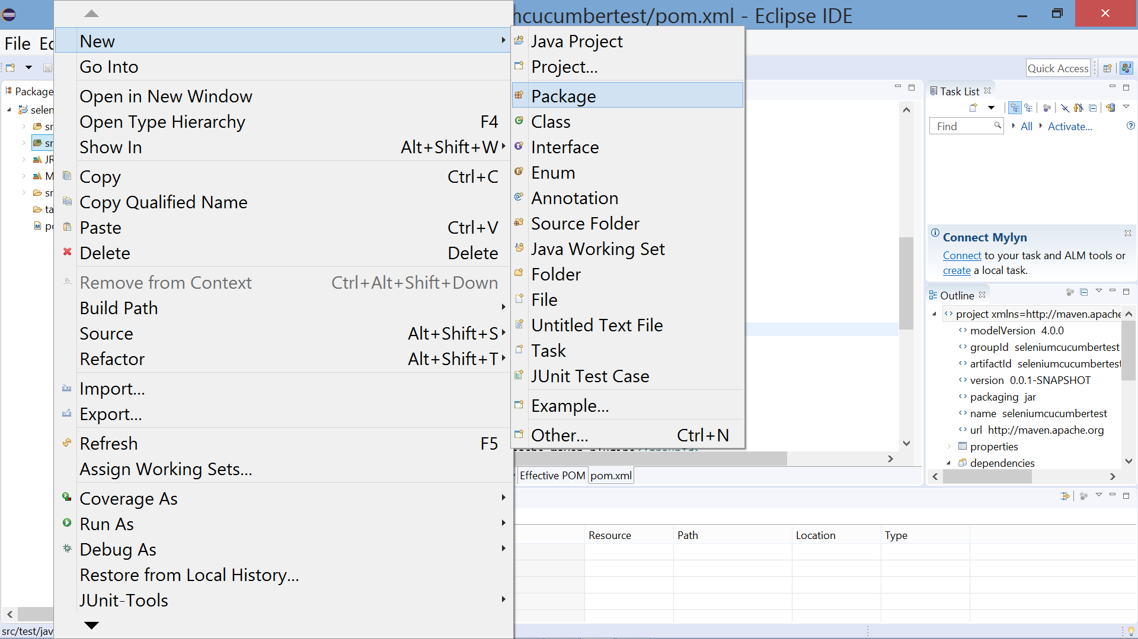

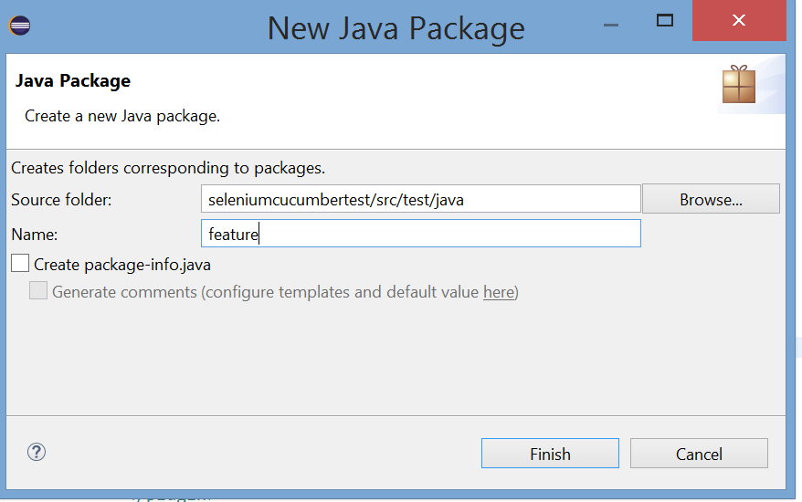

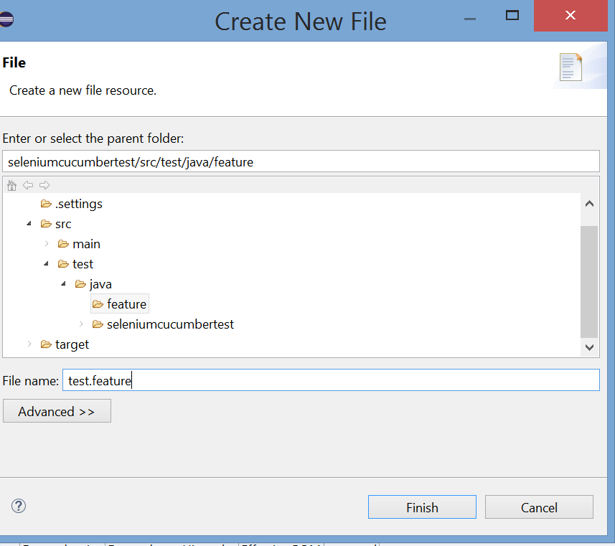

Add steps to the feature file in Gherkin language as framework is BDD

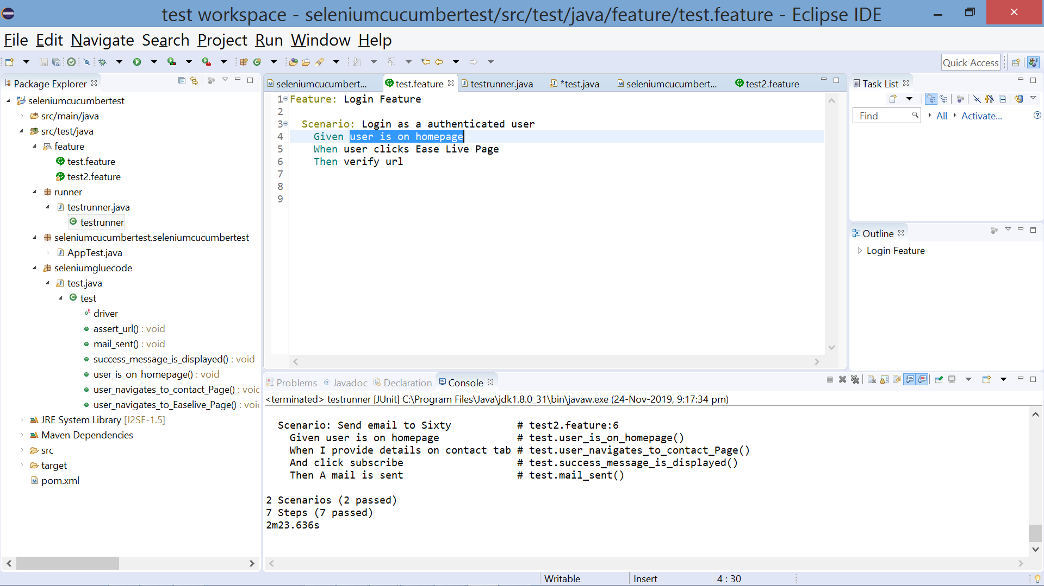

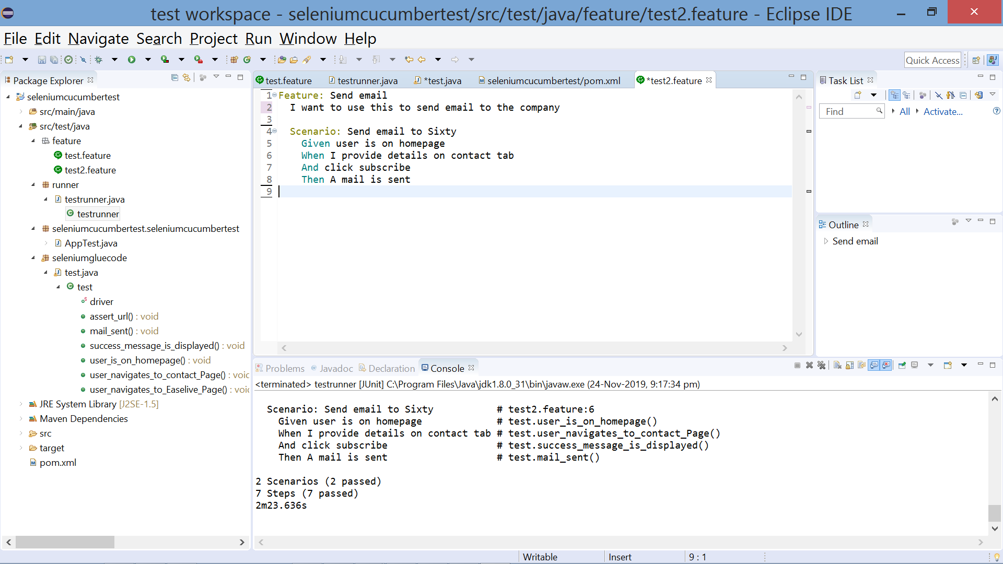

**4. Execute the cases**

Create a new package runner with a java class test.runner

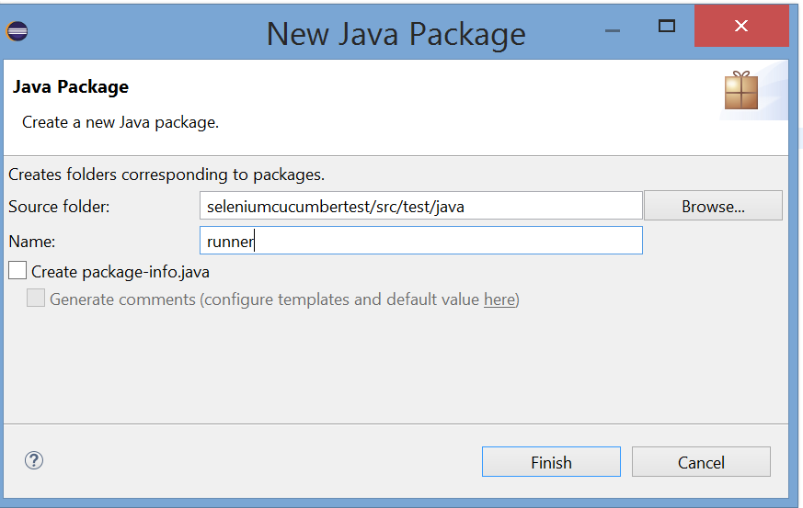

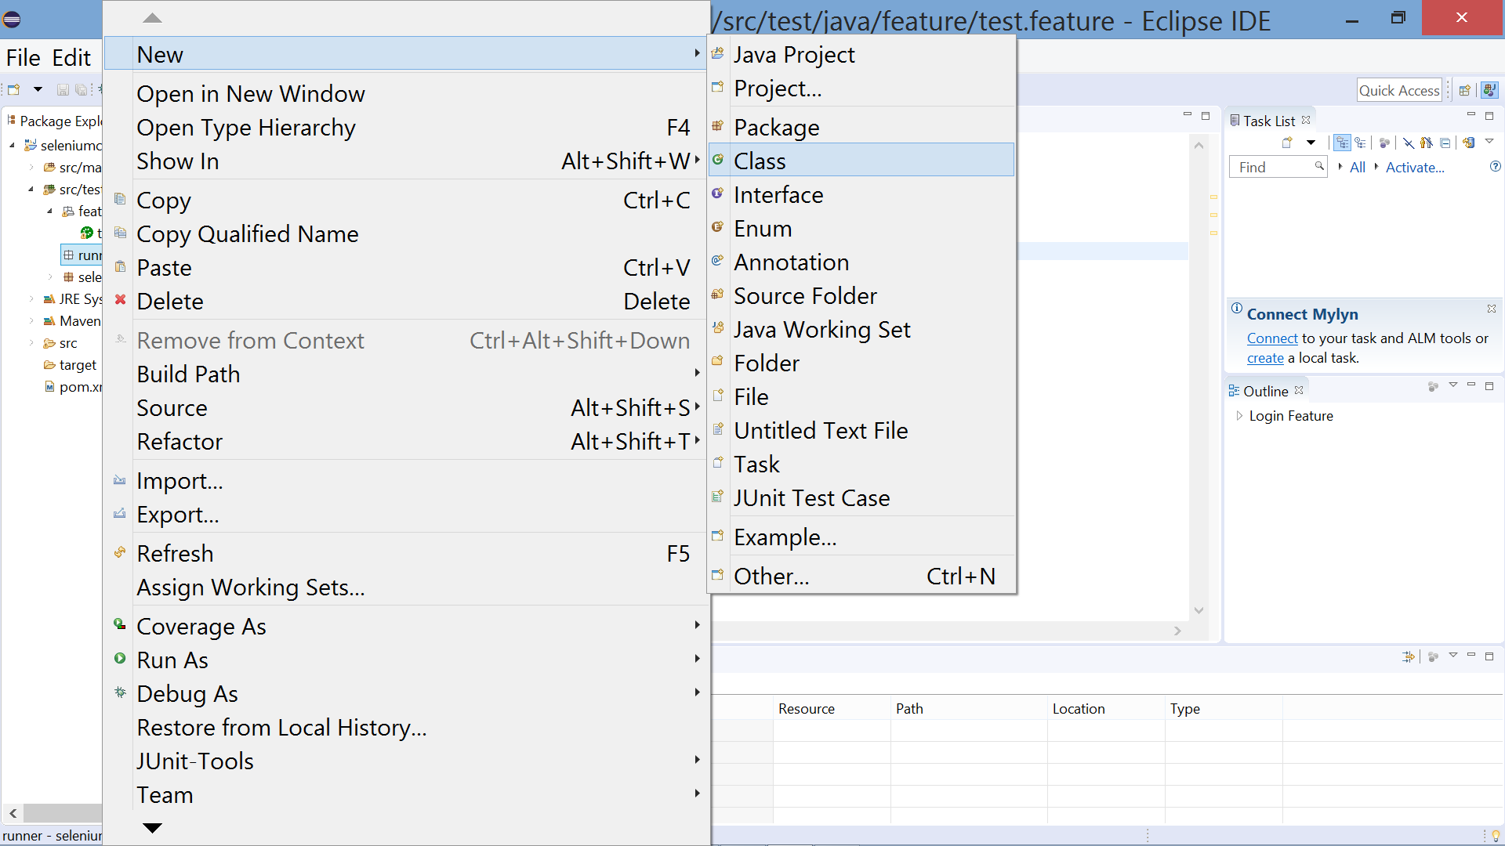

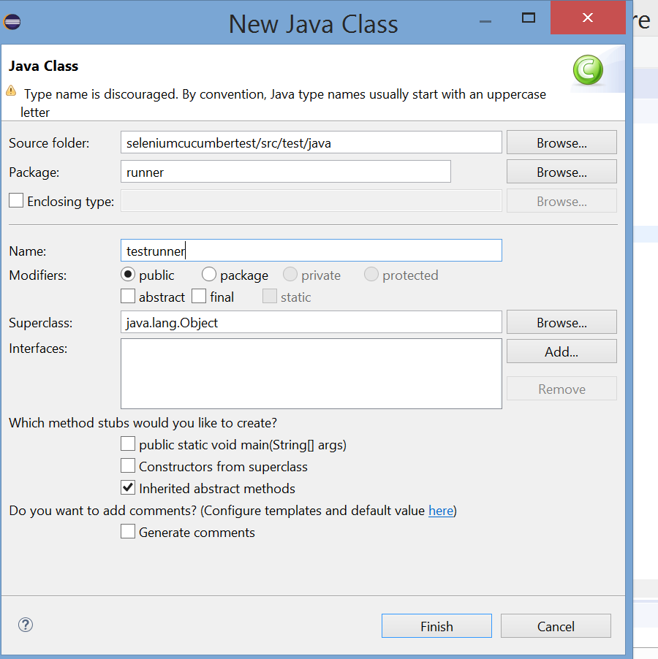

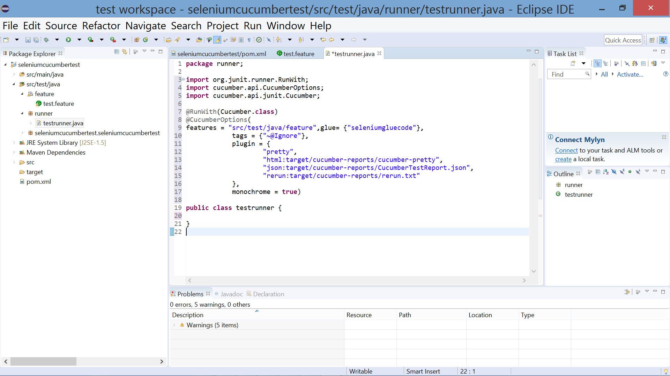

Create a package seleniumgluecode with a java class test.java where the code to each step in feature is mentioned.

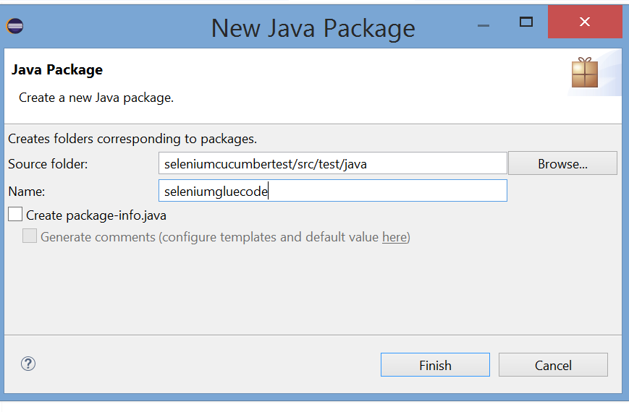

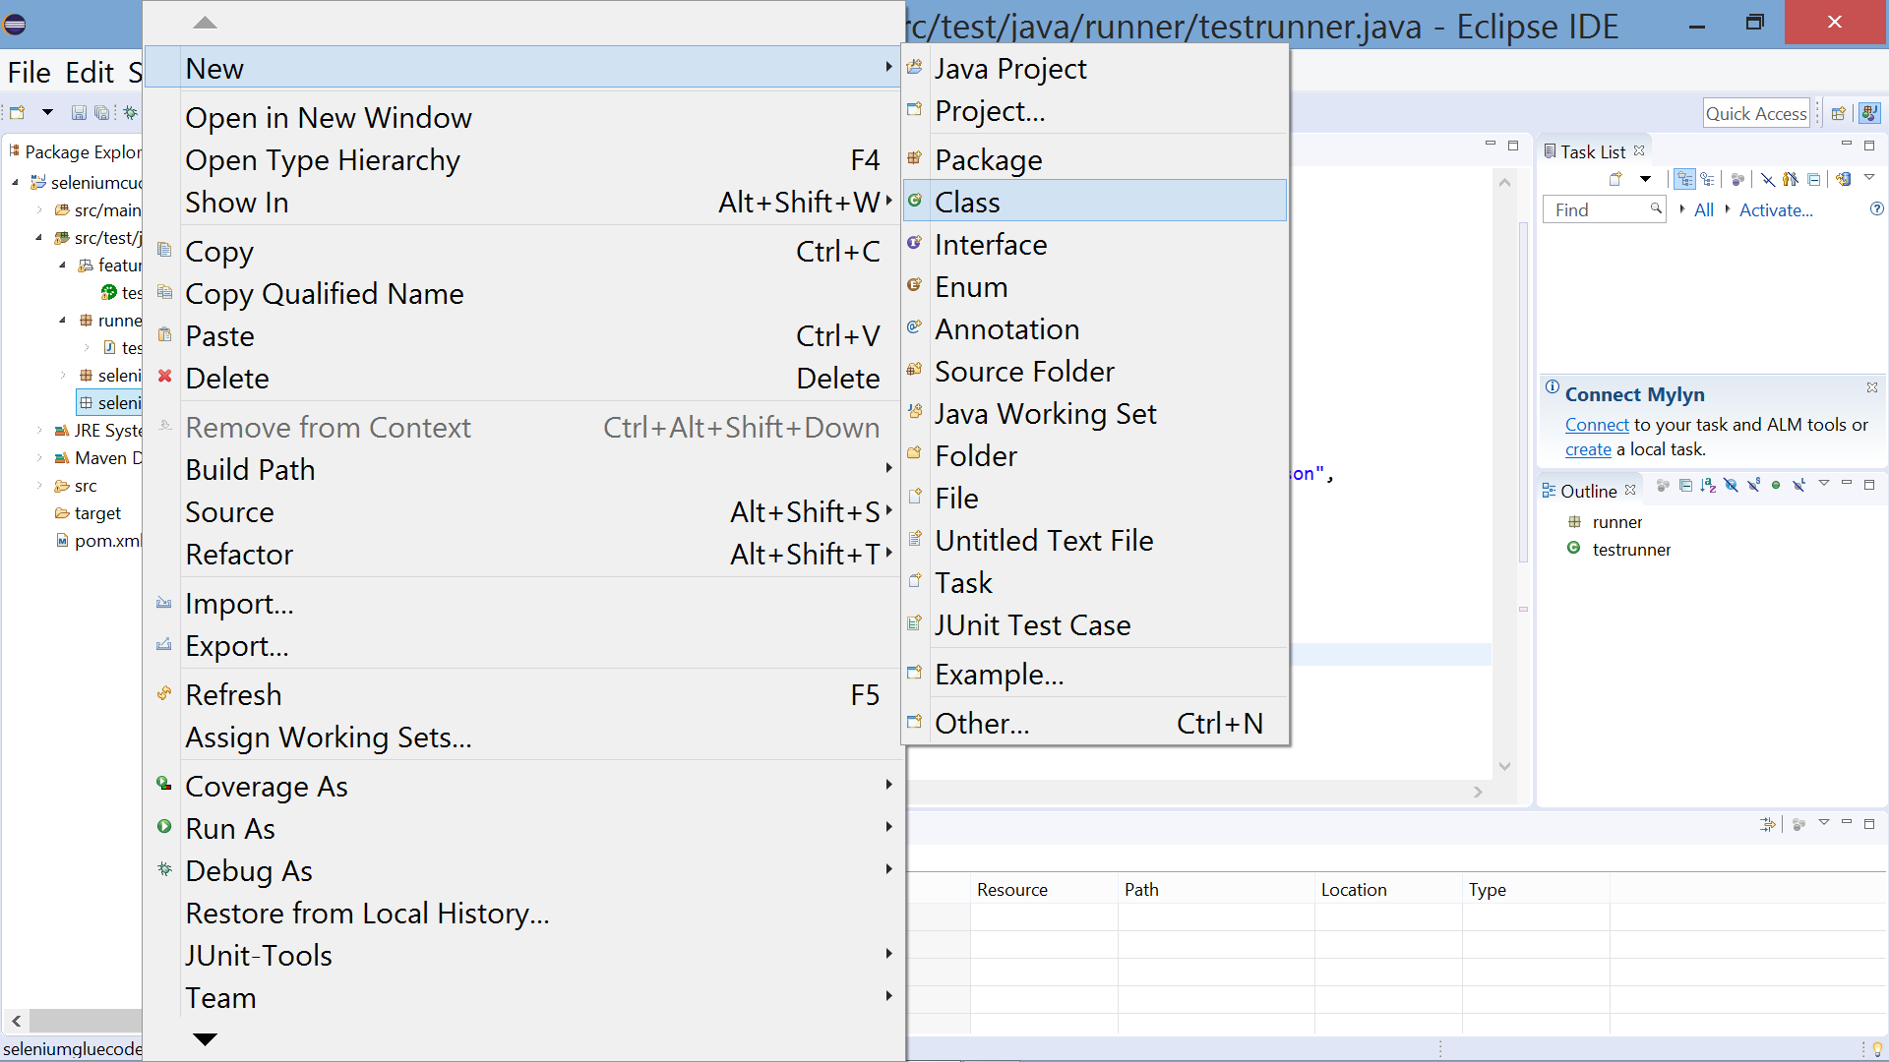

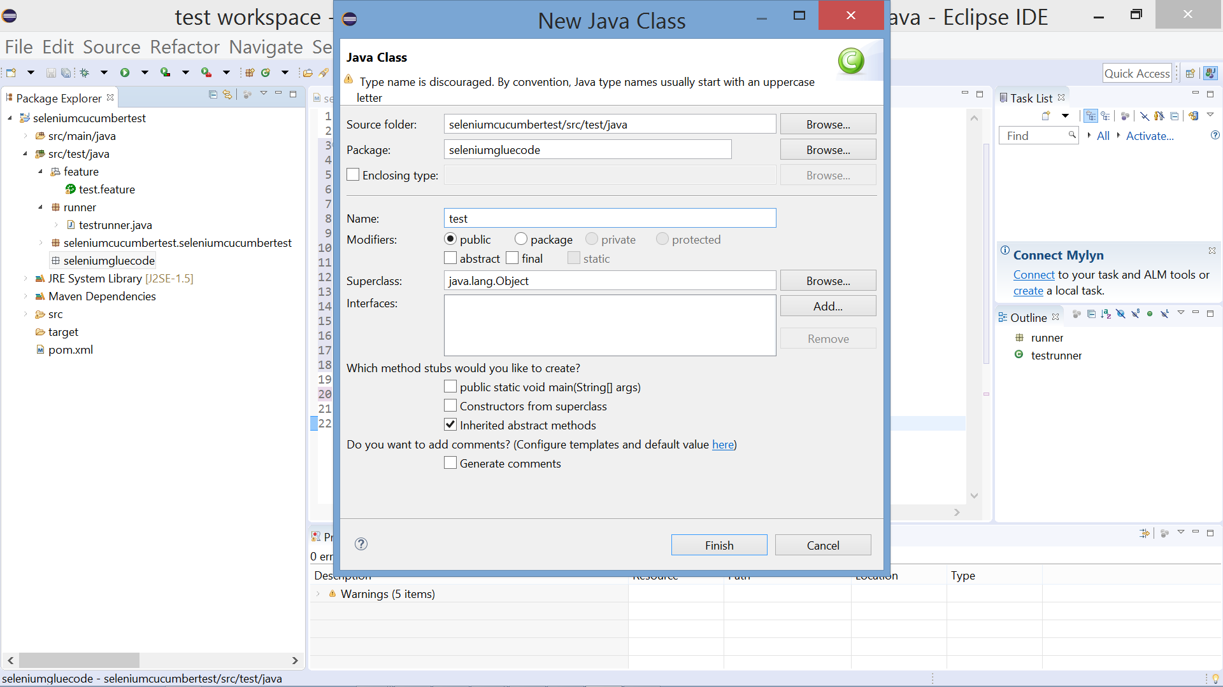

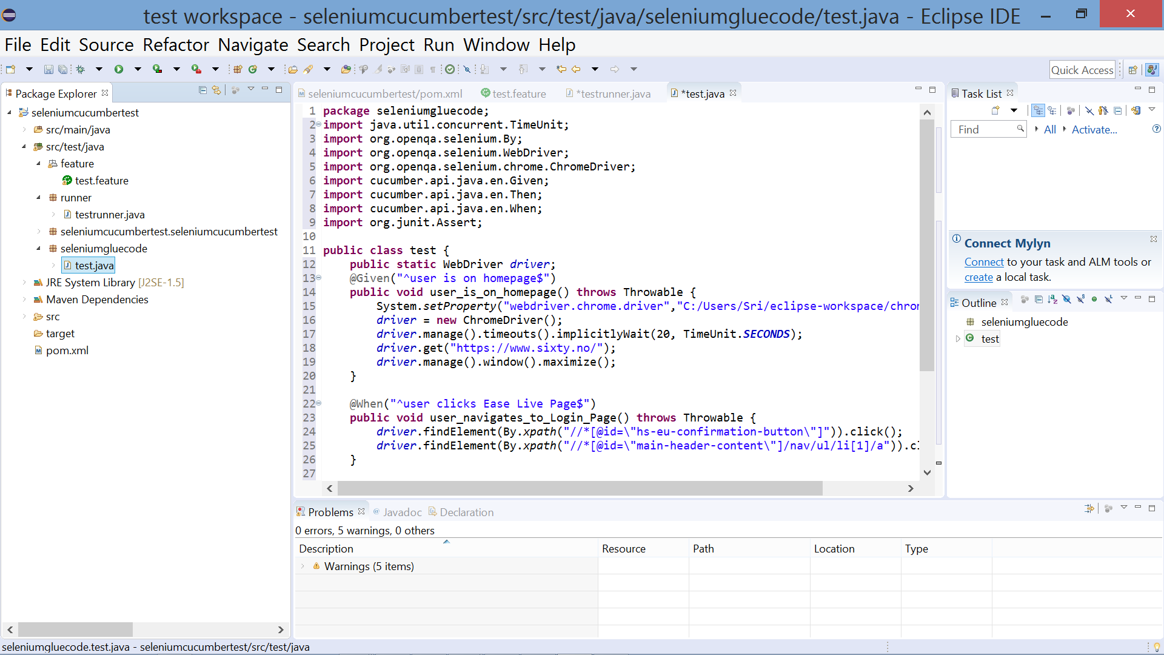

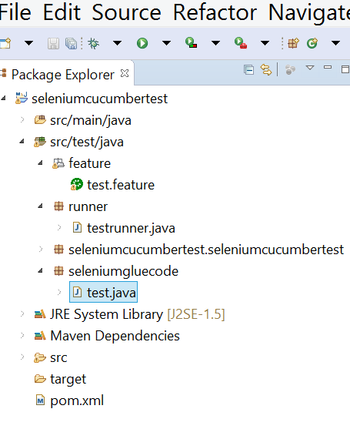

Do a Maven Build with goals as

***org.apache.maven.plugins:maven-compiler-plugin:3.8.1:compile***

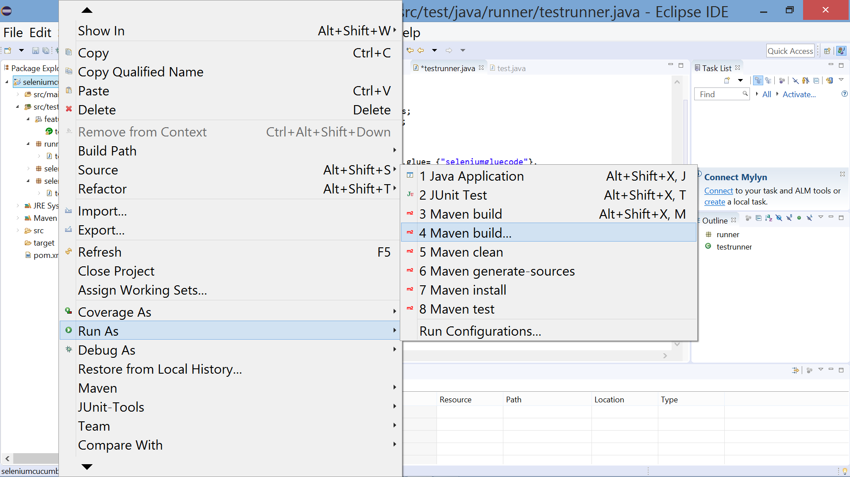

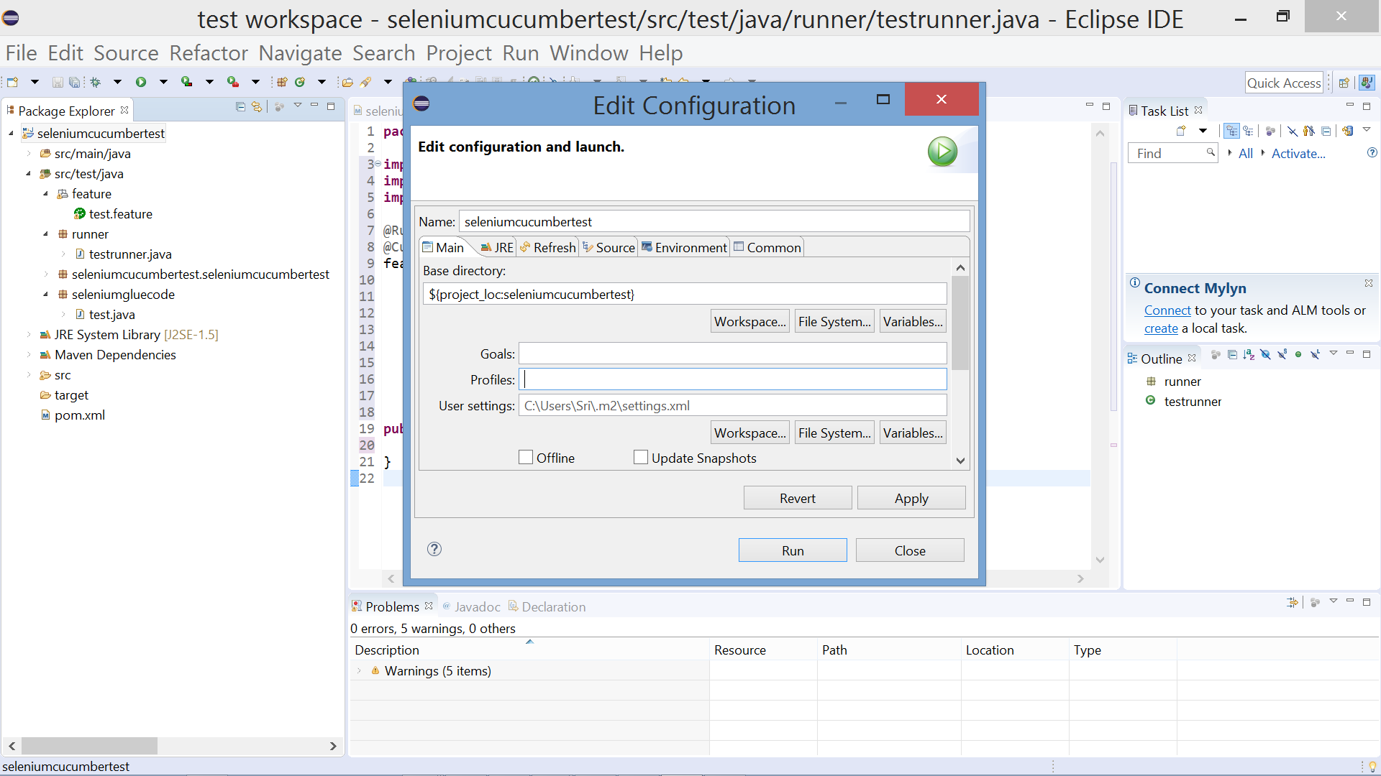

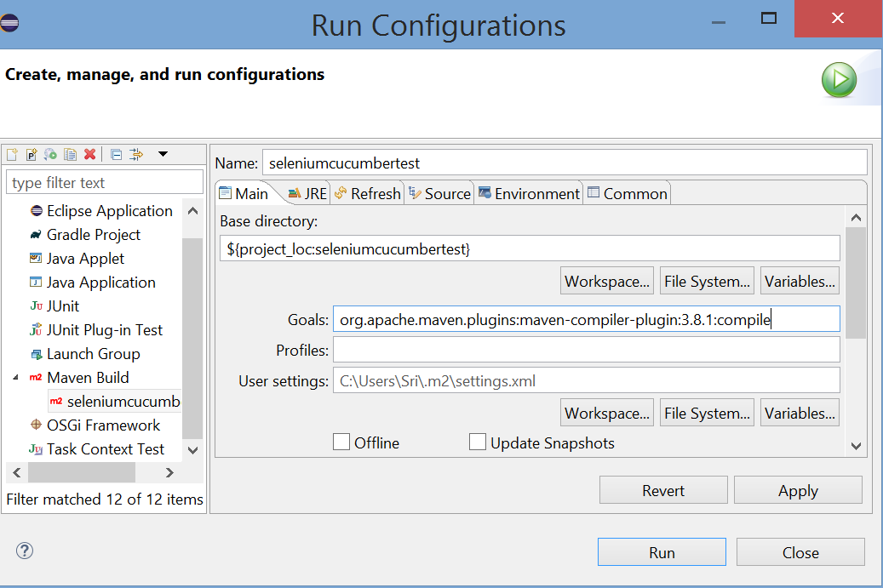

In Run Configuration Apply and run

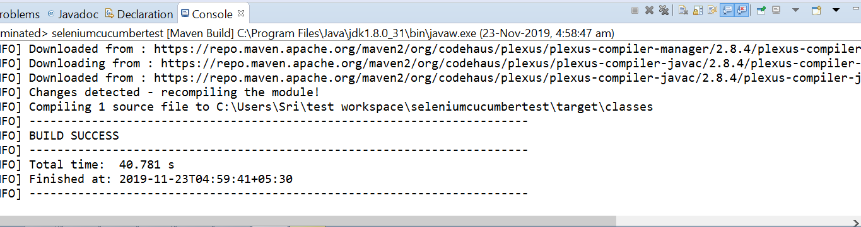

Run testrunner.java as Junit Test

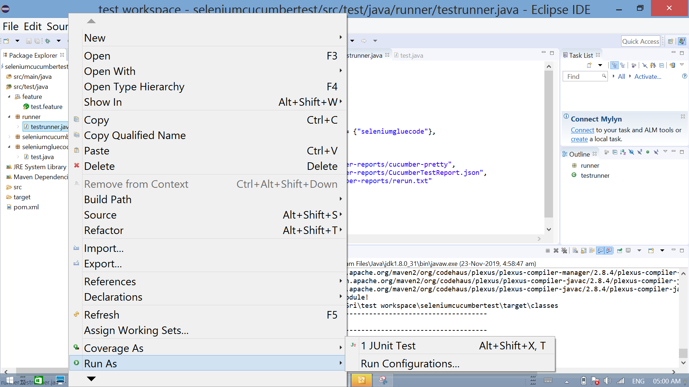



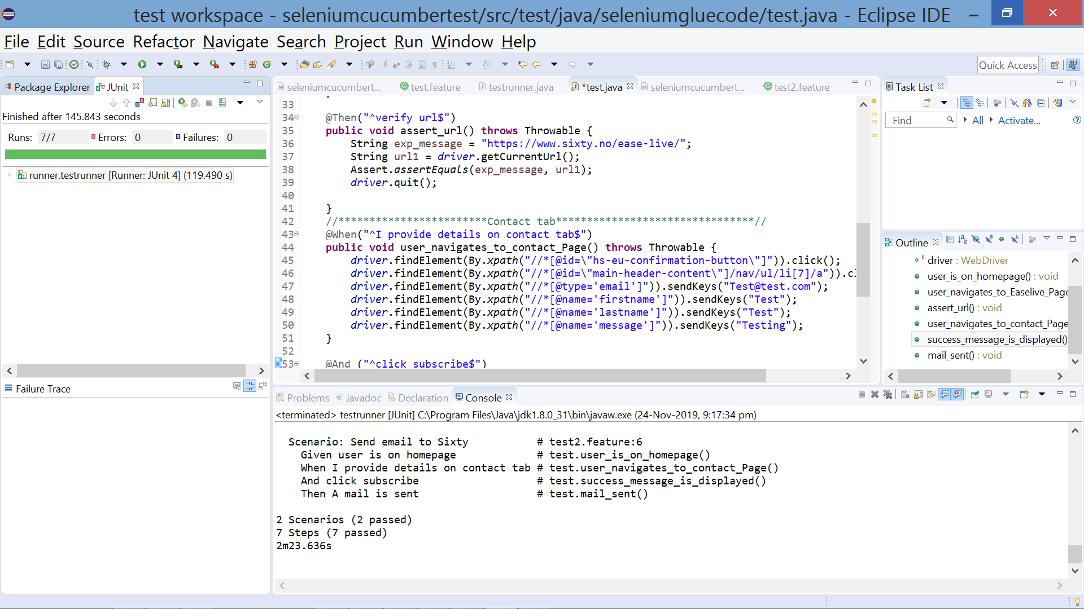

**5. Reports**

Verify the workspace -> seleniumcucumbertest -> target -> cucumber-reports

